HD 166724

HD 166724 is a 0.81 M☉, K0 IV/V star1. The CH survey reported a LPGP with a period of 8100 days, a minimum mass of 4.12 MJup and an eccentricity of 0.77. Based on 39 RV CORALIE measurements obtained between 2001 and 2012 and 55 RV HARPS measurements obtained between 2004 and 2011, a study performed in 2013 (hereafter M13)1 reported a LPGP signal with a period of days, a minimum mass of 3.53 ± 0.11 MJup and an eccentricity of 0.734 ± 0.02.

In the present study, the M13’s dataset[1] was used. DPASS and MCMC (1000 walkers and 400000 iterations) were used to fit the data. A LPGP with a period of 4880 days, a minimum mass of 3.5 MJup and an eccentricity of 0.74 were found with DPASS, with a corresponding rms of residuals of 7.4 m/s, and a LPGP with a period of between 4500 and 6400 days, a minimum mass of 3.5± 0.2 MJup and an eccentricity of were found using MCMC. The properties of HD 166724b are then compatible with those reported in the M13 study. Yet, due to low sampling of the data before the minimum, the period is poorly constrained.

To explore the range of possible values, the semi-major axis was fixed to different values and the data fitted with DPASS. *a* up to 28 au do not significantly change the rms of the residuals (8.4 m/s against 7.4 m/s with *a* left free). In this case (referred to as constrained *a*), the minimum mass is 3.6 MJup and the extremely high eccentricity is 0.95. As the RV curve covers a maximum and a minimum, the stellar offset is well constrained and changing it will not change the possible solutions beyond those found with the constrained semi-major axis.

The fits are shown in Fig 1, and the corner plot in Fig 2, and the results summarized in Table 1.

Conclusion: The properties found in the CH survey for HD 166724b are not confirmed. New data are needed to improve the long term coverage and sampling of the RV variations and further constrain the orbital properties of HD 166724b.

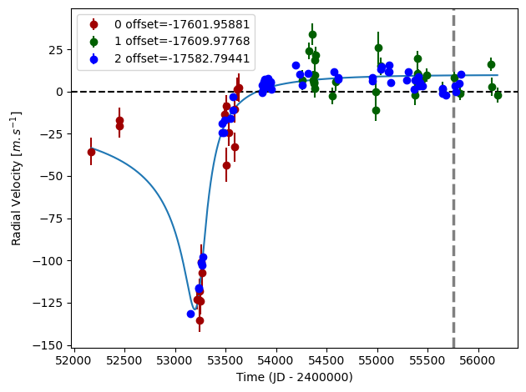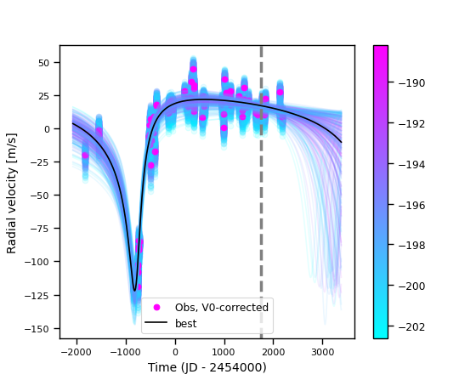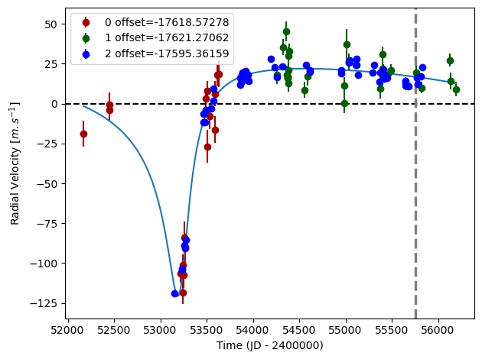

Figure 1: Left: fit of the HD 166724 RV with DPASS. Red - C98, green - C07, blue - H03. The blue curve shows the best fit. Middle: fit of the HD 166724 RV with DPASS, with the minimum a fixed at 28 au. The points are the same as on the left. The blue curve shows the best fit. Right: fit of the HD 166724 RV using MCMC. The black curve shows the best fit. The colorbar corresponds to the log-likelihood of the fits. The gray dotted line indicates the end of the CH survey.

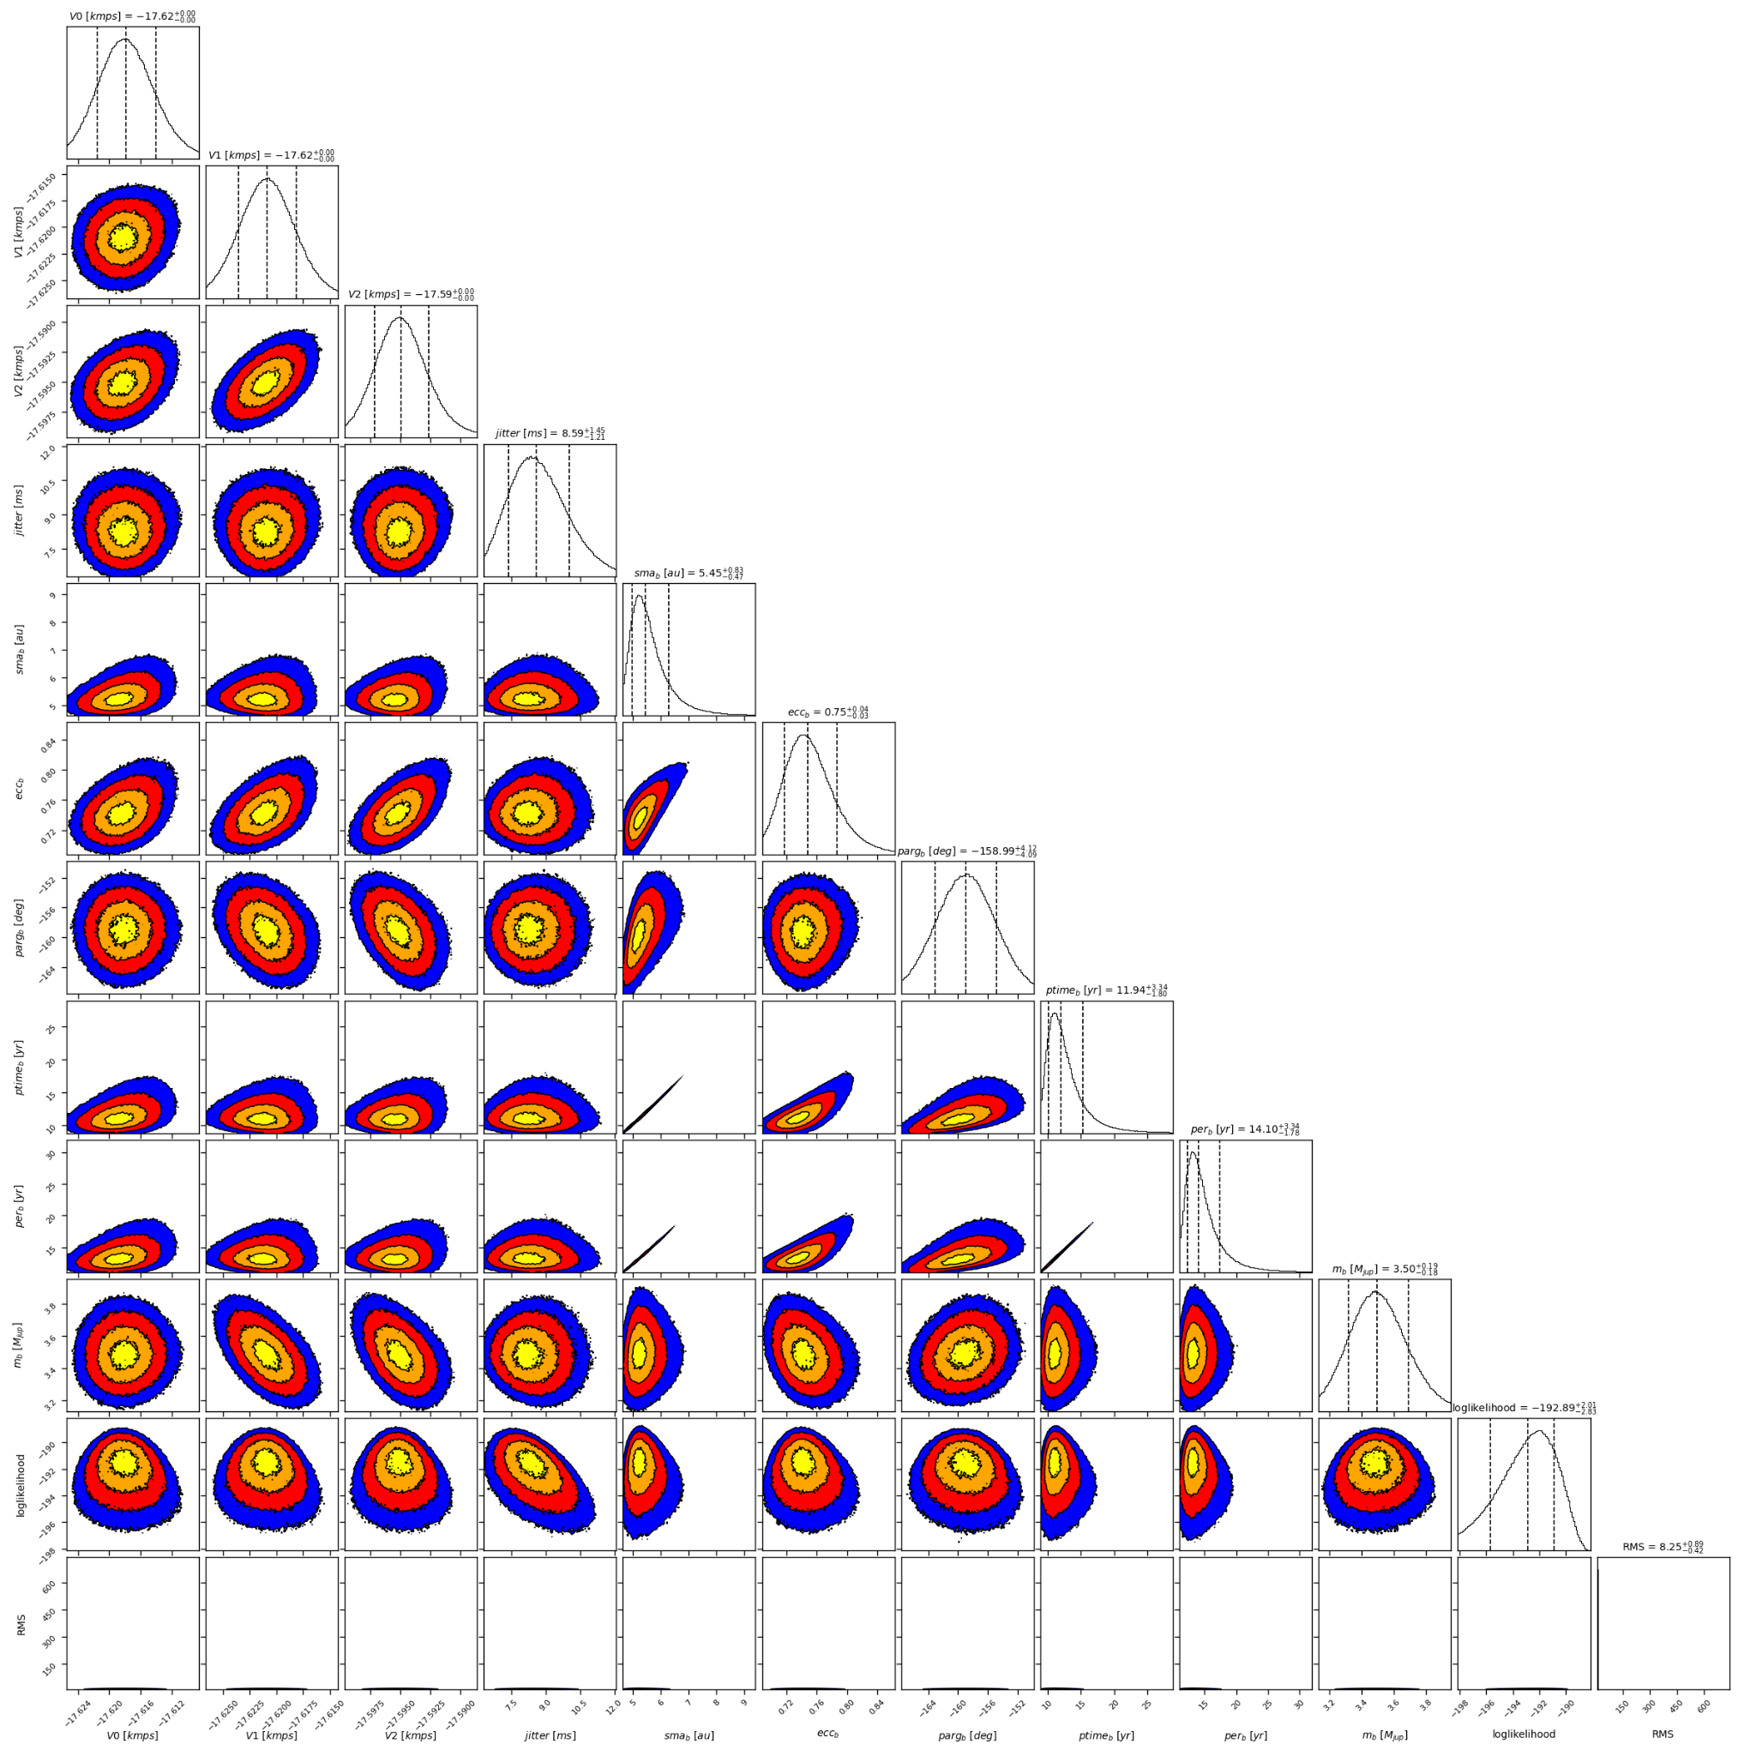

Figure 2: Corner plot of posteriors for the one-planet model MCMC fit of HD 166724 RV data.

| Parameter | Priors | | | Posteriors | | | CH survey |
| --- | --- | --- | --- | --- | --- | --- | --- |
|  | DPASS | | MCMC | DPASS | | MCMC |  |
|  | Free priors | Constrained *a* | Free priors | Free priors | Constrained *a* | Free priors |  |
| *a* (au) | [0,150] | up to 28 | [1,100] | 5.3 | 28 | b = 5.0 – 6.3 | b = 7.4 |
| Msin(i) (MJup) | [0,200] | [0,200] | [0.5,20] | 3.5 | 3.6 | b = 3.5 ± 0.2 | b = 4.12 |
| Eccentricity | [0,0.95] | [0,0.95] | [0,0.95] | 0.74 | 0.95 | b = | b = 0.77 |
| Instrumentals offsets (km/s) | [-100,100] | [-100,100] | [-18,-17] | C98: -17.619  C07: -17.621  H03: -17.595 | C98: -17.602  C07: -17.610  H03: -17.583 | C98: -17.618 ± 0.004  C07: -  H03: -17.595 ± 0.002 |  |
| Stellar jitter (m/s) | [0,40] | [0,40] | [0,20] | 7.2 | 9.3 |  |  |
| Argument of periastron (°) | [0,360] | [0,360] | [0,360] | 200 | 205 | 201 ± 4 |  |
| Phase | [0,1] | [0,1] | [0,1] | 0.91 | 0.89 | 0.85 ± 0.03 |  |

Table 1: HD 166724. Summary of priors and posteriors obtained with DPASS and MCMC, compared to the properties reported by the CH Survey.

References

1. Marmier, M. et al. The CORALIE survey for southern extrasolar planets XVII. New and updated long period and massive planets. *Astron. Astrophys*. 551, A90 (2013).

1. The CORALIE data used were not available on the CDS database; therefore these data were recovered from DACE but they are not exactly the same as those used by the M13 study1 (48 RV CORALIE data against 39 RV CORALIE data). Yet, the RV curve obtained for the CORALIE dataset was the same.